***Name-Sahil Javiya***

***Roll No.- AF0407785***

Lab 2 Questions

1. Write a program that takes a student's score as input and outputs the corresponding grade based on the following scale: A: 90-100, B: 80-89, C: 70-79, D: 60-69, F: 0-59

Input-

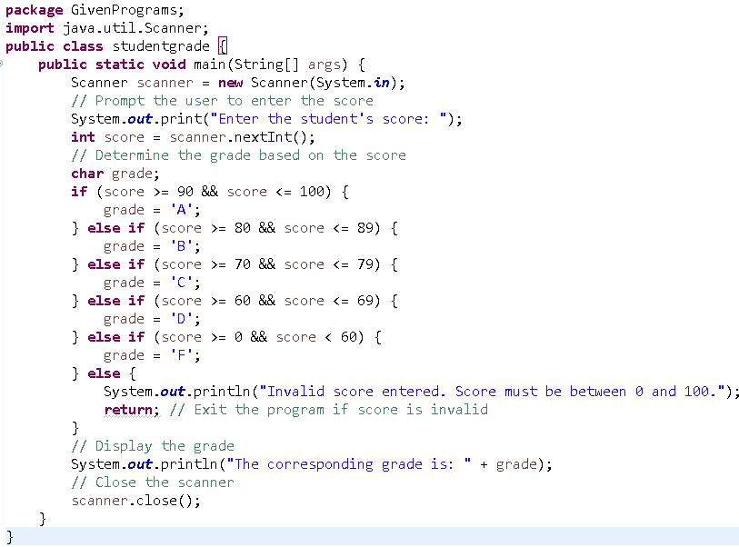Output-

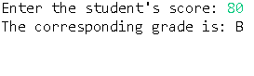

2) Write a program to check if a given year is a leap year. (A year is a leap year if it is divisible by 4 but not by 100, or it is divisible by 400.)

Input-

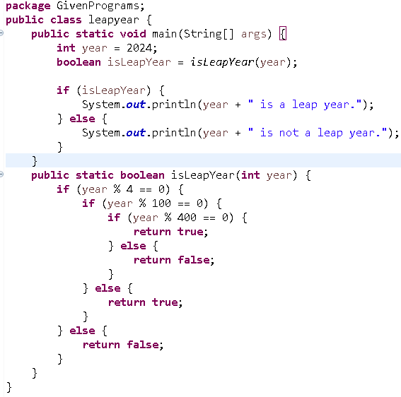

Output-

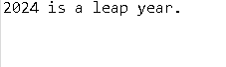

3) Write a program that takes an integer as input and checks if it is positive, negative, or zero.

Input-

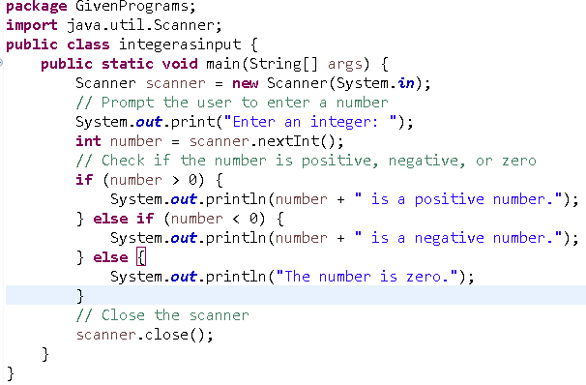

Ouput-

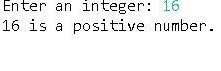

4) Write a program that prints numbers from 1 to 10 using a loop.

Input-

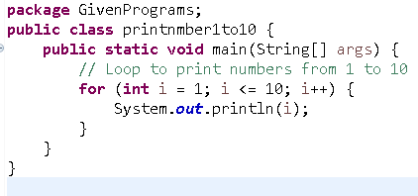

Output-



5) Write a program that takes an integer N as input and calculates the sum of entered numbers.

Input-

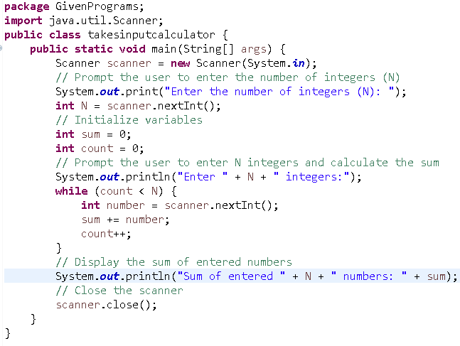

Output-

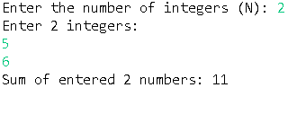

6) Write a program that takes an integer as input and prints its multiplication table up to 10.

Input-

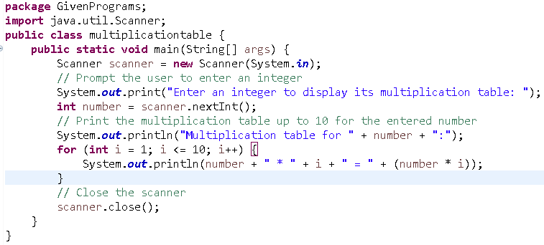

Output-

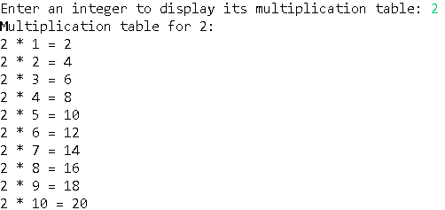

7) Write a program that takes a positive integer as input and prints its digits in reverse order.

Input-

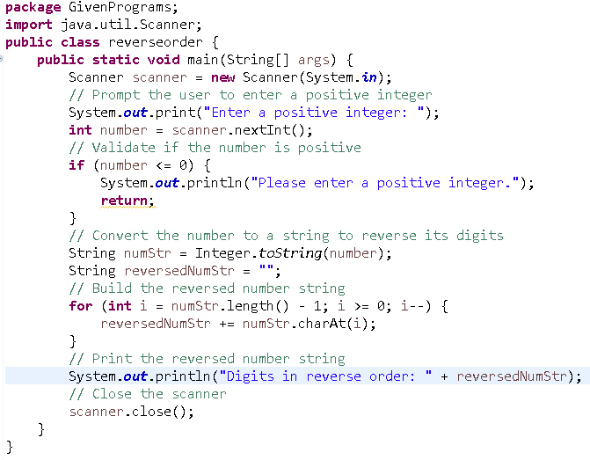

Output-

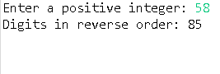

8) Create a class Animal with a method makeSound() that prints "Some generic animal sound". Create another class Dog that extends Animal and overrides the makeSound() method to print "Bark". Write a main method to demonstrate calling the makeSound() method on an Animal reference holding a Dog object.

Input-

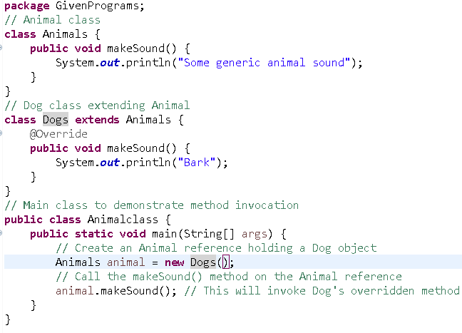

Output-

